- Install PhoenixSuitV1.07_EN software；
- According to the use of 2 small flat-head screwdrivers can also short-circuit.jpg Short-circuit the pin on the device
- Run，select a one-click brush （一键刷机）
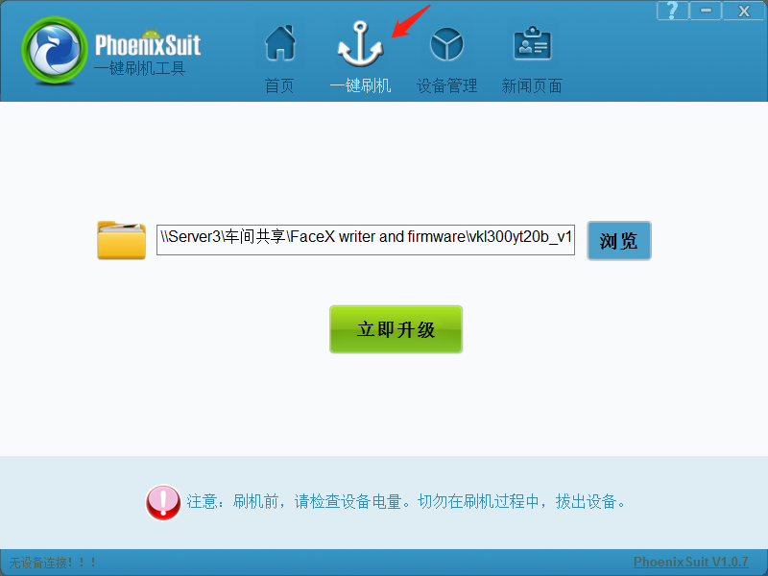

4. Click "Browse" to select the corresponding firmware program in the folder.
5, the computer and the face machine through the USB cable connection. The program will automatically update the program.
6, according to the prompt 2 times to choose to determine. Enter the burning process, the burning is complete, unplug the USB cable and re-disconnect the short-circuited terminal.
7. Power on again.

In the folder without network and 2 groups of firmware with network, the uppercase is the firmware upgraded by the computer, and the lowercase file is the firmware upgraded by the flash drive.

